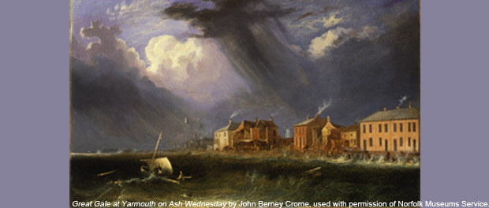

________________________________________________________________________________________________________________________________________________________________________________________________________________________________________________________________________________________________________________________________________________________________________________________________________________________________________________________________________________________________________________________

What do you see in the picture?

Can you see the struggle in the picture?

Imagine that you are in the picture, what is happening?